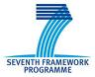 | 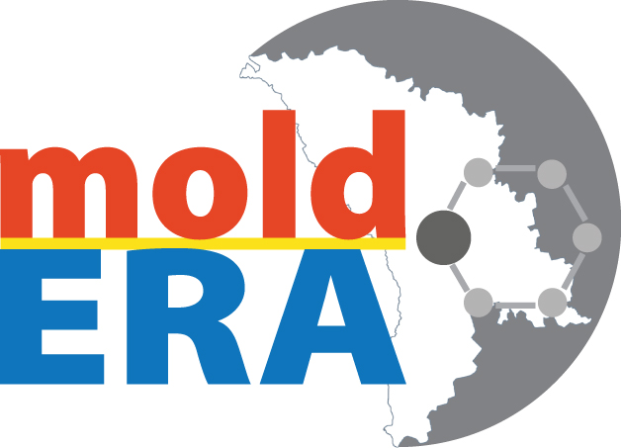

Proposers Workshop
in the framework of MOLD-ERA project
(March 4-6, 2013)

Application Form

Title(Dr.,Mr.,Mrs.,...):
First Name:
Last Name:
Date of birth (dd/mm/yy):
Position:
Department:
Organisation:
Address:
Phone:
Mobile:
Email:
URL:

Please, send the application form to project@mold-era.eu no later than 28 of February, 2013.

